CONSTITUTION AND BYLAWS

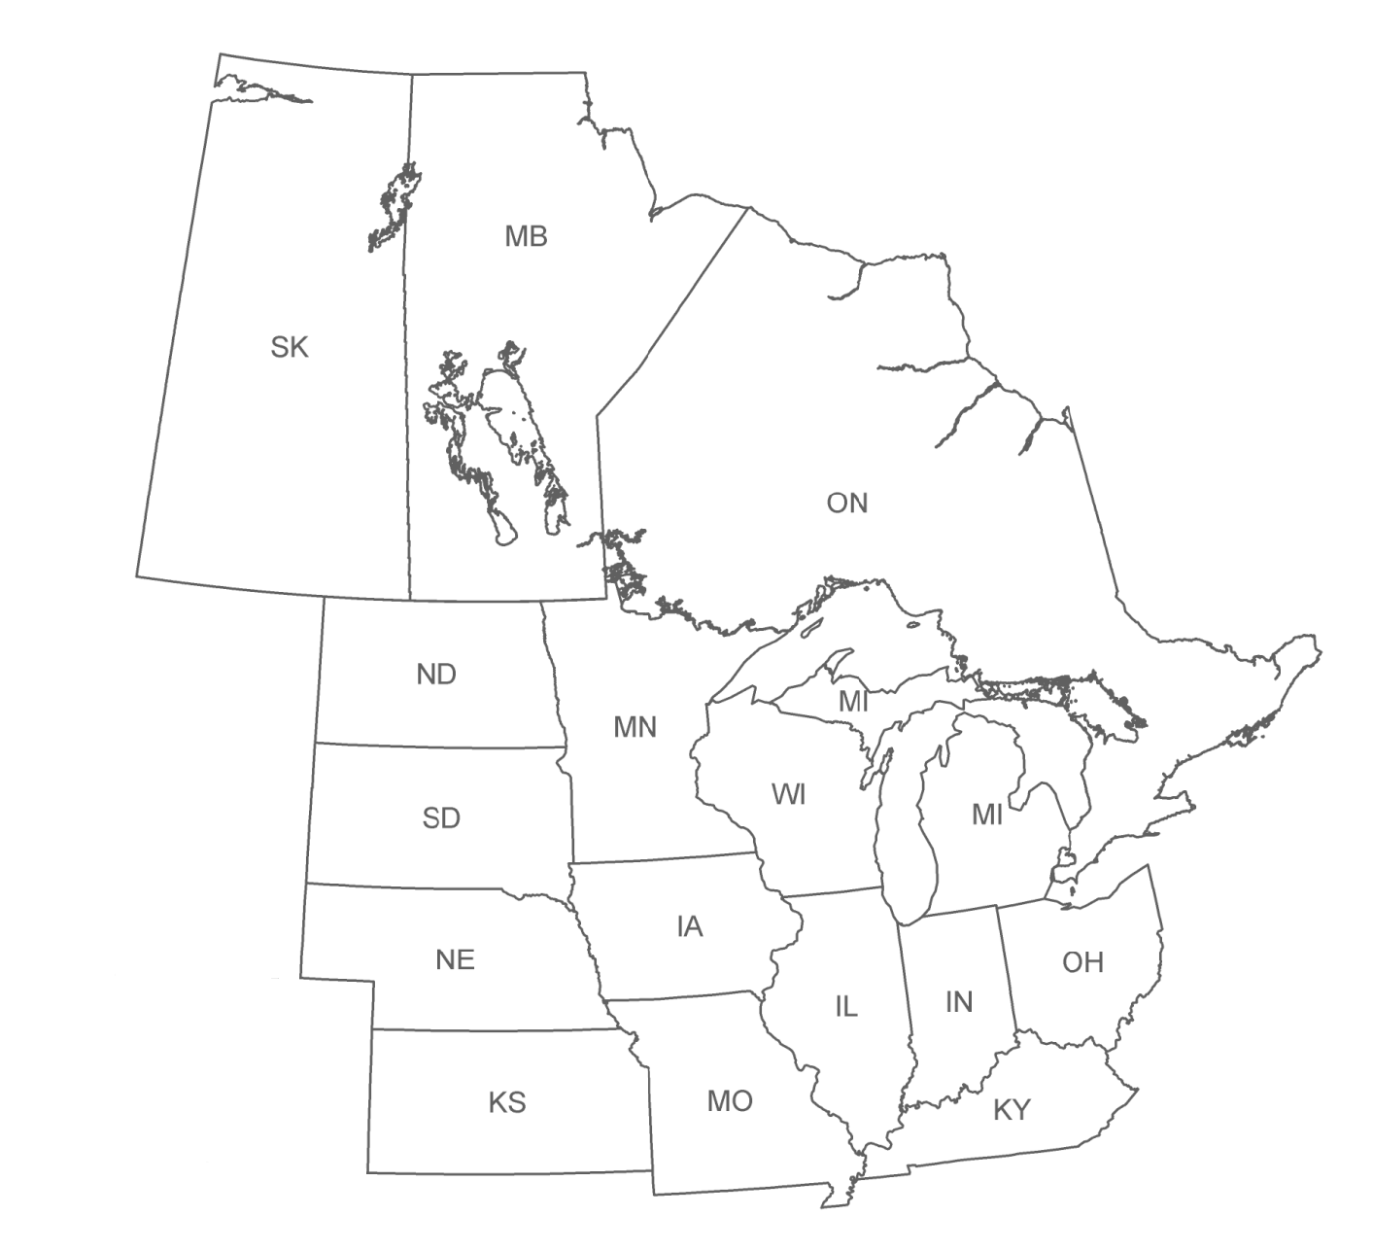

MIDWEST ASSOCIATION OF FISH & WILDLIFE AGENCIES

June 2024

CONSTITUTION AND BYLAWS

MIDWEST ASSOCIATION OF FISH & WILDLIFE AGENCIES
PREAMBLE

The name of this organization shall be the Midwest Association of Fish and Wildlife Agencies (Association). The Association shall be organized and operated as a non-profit professional association as described in 501(c)(6) of the U.S. Internal Revenue Code with the purpose of promoting the protection, preservation, restoration and management of fish and wildlife resources.

The Association established a foundation, Conservation Enhancement Fund (Fund), to be organized and operated as a 501 (c) 3 charitable, educational and scientific corporation.

The Association and Fund were incorporated in the State of Kansas on August 19, 2005. The Association and Fund shall comply with K.S.A. 17-1759, et seq., known as the “Charitable Organizations and Solicitations Act.” To the extent these bylaws conflict with a provision of the Act, the Act shall govern.

The mission of the association shall be:
To provide a common forum for state and provincial fish and wildlife agencies to share ideas, information, pool resources, and form action initiatives to better the management and conservation of fish and wildlife resources in the Midwest.
More specifically, MAFWA strives to:
- Advocate state's rights in fish and wildlife issues.
- Provide information and resources to help states promote and encourage recreational pursuits in hunting, fishing, trapping, wildlife viewing and bird watching.
- Promote efficiencies in government by exchanging research and management information.
- Promote multi-state, range-wide initiatives to keep wildlife species and the habitats on which they depend in healthy, functioning condition.

The objectives of the Association shall be:
(a) to protect the right of jurisdiction of the Midwest states over their fish and wildlife resources on public and private lands and waters;
(b) to scrutinize state and federal fish and wildlife legislation and regulations and to offer support or opposition to legislative proposals or federal regulations in accordance with the best interests of the Midwest states;
(c) to serve as a clearinghouse for the exchange of ideas concerning wildlife and fisheries management, research techniques, fish and wildlife law enforcement, hunting and outdoor safety, and information and education;
(d) and to collaborate and coordinate with our federal partners, conservation organizations and stakeholders for the protection, preservation, restoration and management of our fish and wildlife resources.

The Association met for the first time on October 28, 1934 in Des Moines, Iowa. At that time the group was known as the Association of Midwest Fish and Game Commissioners. The Association first received its non-profit status in 1968. The Association’s name was changed to the Association of Midwest Fish and Wildlife Commissioners in 1972, to the Association of Midwest Fish and Wildlife Agencies in 1977, and to the Midwest Association of Fish and Wildlife Agencies in 2001.

ARTICLE I
OFFICERS
Section 1. The Officers of the Association shall be President, First Vice-President, and Second Vice-President. The President and both Vice-Presidents shall be the duly authorized voting representative of their member state or province and shall be elected by a majority vote of the Board of Directors (Board) present at the regular (annual business) or a special meeting where elections are held from a slate of nominees offered by the Nominations Committee. The term of office shall commence immediately following adjournment of the annual business meeting of the Association and conclude immediately following adjournment of the succeeding annual business meeting.
An Officer’s position that becomes vacant after the annual elections may be filled for the period of the original term by a nominee receiving a majority vote of the Board at any Board meeting with advanced notice of the nominees offered by the Nominations Committee and any nominations made from the floor during the meeting. The Executive Secretary of MAFWA shall call a special meeting if an Officer’s position becomes vacant.

Section 2. The Board of Directors shall be composed of the officers identified in Article I, Section 1 and one representative from each state and province except those represented by the officers. Such state or provincial Board member shall be the chief executive officer of the fish and wildlife agency of his/her state or province, or his/her designee. A Board member may, by written notification to the President, designate a voting proxy from the Board member’s state or province. However, Executive Committee members may not designate a proxy for the conduct of Executive Committee business. All Board members are required to annually sign a conflict of interest and compensation policy form.

ARTICLE II

OTHER ASSOCIATION POSITIONS
Section 1. The Association may establish non-voting positions as required to fulfill its mission.
Section 2. Association contractors are required to annually sign a confidentiality form.

Section 3. Annually the Executive Secretary will conduct performance reviews of the Treasurer and Recording Secretary and verify that all ancillary staff employed under contract conducting business for the Midwest Association of Fish & Wildlife Agencies also receive performance evaluations conducted by the Technical Committee Chair and/or Director Liaison. The Executive Committee will conduct the annual performance review of the Executive Secretary.

ARTICLE III

MEMBERSHIP
Section 1. Membership shall be by states and provinces and representation of each state and province at meetings shall be by its duly authorized representative or representatives.

Section 2. The area of membership in the Association shall be the states of Illinois, Indiana, Iowa, Kansas, Kentucky, Michigan, Minnesota, Missouri, Nebraska, North Dakota, Ohio, South Dakota, and Wisconsin, and the provinces of Manitoba, Saskatchewan and Ontario and such additional states and provinces as may request membership and be elected by majority vote of the member states and provinces in annual meeting.

Section 3. Membership in the Association of an individual shall terminate upon the expiration of the member's term of office as a state fish and wildlife administrator.

Section 4. Other professional organizations may be granted affiliate membership in the Association based upon demonstration that the Constitution and Bylaws of said organizations meet the basic standards of the Association. Application for affiliate membership shall be forwarded to the Executive Secretary at least 90 days prior to a regular meeting of the Association and shall include a current Constitution and Bylaws and a letter stating the organization's justification for affiliate membership. Affiliate membership shall be voted on by the voting representatives and must attain a majority vote of a quorum. Affiliated membership dues shall be $75.00 per year; however, this fee may be waived by a majority vote of a quorum. The fee is automatically waived for affiliated conservation agencies or organizations that provide annual financial resources to support the Association through the following sponsorships: Major Sponsor ($5,000 or more); Gold Sponsor ($3,000-4,999); Silver Sponsor ($2,000-2,999); Bronze Sponsor ($1,000-1,999); and Sponsor ($500-999).

ARTICLE IV
DUTIES OF OFFICERS and OTHER POSITIONS
Section 1. The President shall preside at all meetings of the Association, appoint all special committees, preside at meetings of the Board of Directors, and perform such other duties as are naturally incumbent upon the office to serve the Association and the Fund. Copies of the annual proceedings shall be available electronically to each member in good standing, with the cost of preparation and handling to be paid out of Association funds.

Section 2. The First Vice-President shall perform the duties of the President in the latter's absence, and specific duties may be assigned as deemed necessary by the President.

Section 3. The Board of Directors shall conduct the business of the Association.

ARTICLE V
MEETINGS
One regular business meeting shall be held annually and hosted by each member state as its turn comes due in a rotation as determined by alphabetical order. It is the intent of the Association that the costs of the annual business meetings and related business functions shall be paid by the host state and the Association. When necessary, special meetings may be called by the President or the Executive Secretary. Members shall be given 90 days’ notice of regular annual meetings; 60 days’ notice for special, in-person meetings; and five days’ notice for special, telephonic meetings and telephonic meetings of the Executive Committee.

The Association may authorize members, affiliates and other groups to exhibit at its meetings, subject to the Exhibitor/Sponsor Policy approved by the Board of Directors.

ARTICLE VI
VOTING
Voting shall be by states and provinces, as units. Each state and province shall have one vote. All voting shall be by voice vote, except that a reasonable request by any member state or province for a secret ballot shall be honored. Any matters of Association business requiring action in the interim between meetings may be handled by the Executive Committee, by majority vote of that committee.

ARTICLE VII
DUES
Annual Dues shall be payable in advance, at, or before each annual business meeting; provided that annual dues may be suspended for any given year by a majority vote of a quorum. Dues shall be adjusted annually by the Consumer Price Index for All Urban Consumers (CPI-U) in the Midwest published by the United States Bureau of Labor Statistics. Dues shall be adjusted using the annual change in the CPI-U for the month of January of the previous fiscal year. The annual dues for the upcoming year shall be reported at the Association’s regular annual meeting by the Treasurer.

ARTICLE VIII
FISCAL YEAR
The fiscal year of the Association shall be January 1 through December 31.

ARTICLE IX
QUORUM
A quorum is defined as a simple majority of the states.

ARTICLE X
AMENDMENT
The Constitution and Bylaws (Bylaws) of the Association may be amended at any regular meeting by a majority vote of a quorum; provided, however, a written copy of such proposed amendment shall have been received by the President and the Executive Secretary and sent to members at least 30 days before the regular annual meeting or special meeting called for that purpose; and provided that such changes shall be effective only to the extent they are authorized by applicable law. Proposed Bylaws amendments should be presented to, or generated by, the Bylaws Committee and reviewed by the Executive Committee prior to submitting to voting members of the Association for their consideration. With approval of the First Vice-President, the President may call for voting by mail (including electronic mail) in lieu of a meeting. In this event, the 30-day notice shall still apply, the date of opening ballots shall be previously announced, notice sent to each member within forty-eight hours of vote tabulation by the Executive Secretary and all ballots shall be kept for one year following the vote.

ARTICLE XI
TYPES OF COMMITTEES/BOARDS
Section 1. There shall be three kinds of committees: Standing, President’s Ad Hoc, and Technical Working.

Section 2. The following Standing Committees, except the Nominations Committee, shall be appointed by the incoming President within 60 days after assuming office, they shall serve during the period intervening between annual meetings and at such meetings, or until the purpose of each such committee has been accomplished and it has been discharged by the President.

- The Executive Committee shall be composed of six members of the Association: The President, First Vice President, Second Vice-President, Past President, and two other members to be appointed by the President with specific consideration for geographical balance. Any state or province represented on the Executive Committee by more than one individual shall be restricted to a single vote on this committee. The Executive Committee shall have general supervision of the affairs of the Association between its business meetings, make recommendations to the Association as necessary and shall perform such other duties as may be specified in these bylaws. The Executive Committee shall be subject to the orders of the Board of Directors and none of its acts shall conflict with action taken by the Board of Directors. Special meetings of the Executive Committee may be called by the President as necessary. The Executive Committee may also act via conference call or by mail (including electronic mail).

- The Nominations Committee shall be composed of three members appointed by the Board who will name one as Chairman. The committee shall provide at least one nominee for each office. Nominations also may be made from the floor during the regular or the special meeting where elections are held.
- The Budget and Finance Committee shall be composed of three members; the President and two other members to be appointed by the President. There shall be one sub-committee, the Audit Committee, that reports directly to the Budget and Finance Committee. The Budget and Finance Committee shall work with the Executive Secretary and the Treasurer to develop a budget including review of investments and other permanent assets of the Association and make recommendations to the Association per the investment policy statement. On an annual basis, prior to the Annual Board Meeting, requests for funding from Technical Committees shall be reviewed and recommendations considered for inclusion in current and future budgets. Recommendations considered viable for funding and inclusion in current or future budget, shall be submitted to the Executive Committee for approval in a meeting prior to the Annual Board Meeting. Annually a report on the status of the current budget, projected future fiscal year budget, including approved recommendations from the Executive Committee shall be presented at the meeting of the Board of Directors.
  - The Auditing Committee shall be composed of three members: The First Vice President of the Association, who shall act as chairman, and two other members to be appointed by the President. The Auditing Committee shall audit the financial records of the Association semi-annually and report the result of its audit to the Budget and Finance Committee in order to implement changes and/or adjustments required into the budget and at the annual regular meeting. An external audit by a CPA firm approved by the Executive Committee shall be conducted every five years.

- The Resolutions Committee shall be composed of three members, one of which shall be designated as Chairman by the President. Copies of proposed resolutions should be received by the President and the Executive Secretary and sent to members for their consideration at least 30 days before the regular annual meeting. Courtesy resolutions and resolutions of a last-minute nature may be recommended to the Board of Directors at the annual meeting. Furthermore, proposed resolutions for which an urgent need arises between annual meetings may be presented to the Board of Directors for consideration via mail (including electronic mail), provided members are given a 15-day notice. Members shall be notified of the vote outcome by the Executive Secretary within forty-eight hours of vote tabulation.

- The Awards Committee shall be composed of five members, one of which shall be designated as Chairman by the President. The Awards Committee shall administer the official annual awards program of the Association.

- The Bylaws Committee shall be composed of two members one of which shall be , designated as chairman by the President. The Bylaws Committee shall recommend Bylaws changes to the Executive Committee for consideration.

- The Program Committee shall be comprised of the previous conference host Director, the current host Director (who shall serve as Chairman), the incoming host Director and the Executive Secretary.. Each year, at least six months prior to the Annual Meeting, this committee shall query members of MAFWA for program topics to be included. Topics could be emerging issues, innovative initiatives, or issues of opportunity or concern identified in Technical Working Committees.

- The Midwest Landscape Initiative Steering Committee shall be comprised of five Directors and three senior representatives from the US Fish and Wildlife Service, one from the US Forest Service, and one from the US Geological Service in the MAFWA region. The Midwest Landscape Initiative is a collaboration of partners engaged in the conservation and management of fish and wildlife in the Midwest; it serves as forum to identify shared landscape-scale priorities and co-develop effective conservation actions to address them. The Steering Committee may include ex officio members and may form subcommittees, working groups, teams, or other collaborative approaches to aid in the development and implementation of effective conservation solutions for shared priorities.

Section 3. Ad Hoc Committees may be established as deemed necessary by the President of the Association or vote of the Members at any time Ad Hoc Committees will have one year to operate in order to fulfill the mission they were charged. If the work will take longer than 1 year from Presidential request or vote, the Ad Hoc Committee shall develop a charter, as detailed in the Guideline Manual for Technical Working Committees, submit to the Executive Committee for review and approval before final submission to the Board of Directors for formal establishment as a Technical Committee. If an Ad Hoc Committee is created halfway through a fiscal year, they shall prepare and present a report of work to the Board of Directors at their Annual Meeting.

Section 4. The Association may establish Technical Working Committees as deemed necessary to conduct the affairs of the Association. Upon establishment, these committees shall adhere to the following:

- Within one year from establishment, each committee shall submit to the Executive Committee for review a charter, listing goals, objectives and specific responsibilities of the Committee, and a description of operating procedures, as per the Guideline Manual for Technical Working Committees. This document will become part of the official minutes of the Association upon presentation and approval by the Board of Directors.

- All Technical Working Committees shall submit a written report, as per the Guideline Manual for Technical Working Committees, electronically to the President and the Executive Secretary 60 days in advance of the annual meeting of the Association and may choose to conduct necessary committee business during the period between annual meetings as per their approved operating procedures.
- Resolutions or funding requests from Technical Working Committees intended for Association action shall be developed in partnership with the Committee’s Director Liaison who will submit the request to the Executive Committee for their review prior to assignment to the Resolution or Budget Standing Committees. Final resolutions or funding requests by the appropriate Standing Committee shall be submitted to the Executive Secretary at least 30 days in advance of the annual meeting for consideration by the Board of Directors.

- Each Technical Working Committee shall be automatically abolished by the first of August every three years unless reinstated by vote of the Association. As the end of the third-year approaches, the Technical Committee shall prepare a retrospective analysis, as per the Guideline Manual for Technical Working Committees, for work accomplished during the three-year term and update the Committee’s charter if working to achieve new goals, objectives in the future term. The retrospective and new charter will be submitted to the Executive Committee for review at a meeting prior to the Annual Board Meeting. If approved by the Executive Committee, the Association shall assess the merits of reinstating the Technical Working Committee.

- The Association recognizes the following Technical Working Committees (year of automatic abolishment in parentheses):

Climate Change (2025)
Midwest Private Lands Wildlife Management Group (2027)
Midwest Public Lands Technical Working Committee (2025)
Midwest Fish and Wildlife Health Committee (2025)
Midwest Deer and Wild Turkey Study Group (2026)
Association of Midwest Fish and Game Law Enforcement Officers (2026)
Midwest Furbearer Group (2027)
Wildlife Diversity Committee (2027)
Midwest R3 & Relevancy Committee (2026)
Conservation Social Science/Human Dimensions Committee (2027)
Feral Swine Committee
Chronic Wasting Disease Committee
Midwest CITES

ARTICLE XII

PARLIAMENTARY AUTHORITY

The rules contained in the current edition of Robert’s Rules of Order Newly Revised shall govern the Association in all cases to which they are applicable and in which they are not inconsistent with these bylaws and any special rules of order the Association may adopt.

Adopted 1936
Amended 1942
Amended 1944
Amended 1949
Amended 1954
Amended 1960
Amended 1964
Amended 1969
Amended 1971
Amended 1972
Amended 1975
Amended 1976
Amended 1977
Amended 1978
Amended 1980
Amended 1987
Amended 1993
Amended 1995
Amended 1996
Amended 2000
Amended 2001
Amended July 16, 2003
Amended July 13, 2004
Amended July 13, 2005
Amended July 12, 2006
Amended July 18, 2007
Amended July 2, 2008
Amended July 1, 2009
Amended December 23, 2009
Amended June 29, 2011
Amended June 27, 2012
Amended June 26, 2013
Amended June 25, 2014
Amended July 1, 2015
Amended June 29, 2016
Amended June 28, 2017
Amended June 27, 2018
Amended June 26, 2019
Amended October 8, 2020
Amended June 30, 2021
Amended June 30, 2022
Amended June 28, 2023
Amended November 6, 2023
Amended June 26, 2024

